Finance and Insurance • 52315


Investment Banking & Securities Intermediation in the US

Demetrios Berdousis Published: June 2026

2026 IBISWorld. All Rights Reserved www.ibisworld.com

About

IBISWorld specializes in industry research with coverage on thousands of global industries. Our comprehensive data and in-depth analysis help businesses of all types gain quick and actionable insights on industries around the world. Busy professionals can spend less time researching and preparing for meetings, and more time focused on making strategic business decisions.

Table of Contents

1. Risk Overview ....................................................................................... | 1 | Volatility ....................................................................................................... | 6
Recent Developments ............................................................................. | 1 | 3. Growth Risk ......................................................................................... | 8
Industry Definition & Activities ............................................................. | 1 | Growth Risk Score .................................................................................. | 8
Industry Risk Score .................................................................................. | 2 | Growth Risk Analysis ............................................................................. | 8
Risk Rating Analysis ................................................................................. | 2 | 4. Sensitivity Risk .................................................................................... | 9
2. Structural Risk .................................................................................... | 5 | Sensitivity Risk Score .............................................................................. | 9
Structural Risk Score .............................................................................. | 5 | Sensitivity Risk Analysis ......................................................................... | 9
Barriers to Entry ....................................................................................... | 5 | 5. Risk Score Methodology ............................................................... | 21
Competition ............................................................................................... | 5 | What is Industry Risk? .......................................................................... | 21
Domestic And International Markets ................................................ | 6 | Industry Risk Scoring Methodology ................................................ | 21
Assistance .................................................................................................. | 6 | Risk Rating Score Ranges ................................................................... | 21
Life Cycle .................................................................................................... | 6

Risk Overview

Recent Developments

Companies Overview

Major companies adapted to higher interest rates and less liquidity. After nearly 15 years of quantities easing, the Federal Reserve is reducing its balance sheet to help control inflation.
Environmental, social and governance (ESG) are becoming more critical to companies. Companies either choose to invest based on ESG factors or create a more inclusive and diverse working environment.

Competitive Forces

Economies of scale are essential. Investment banking and securities intermediators with the best and most cost-effective technological networks are more competitive.
Zero commission fees on trading push companies to create better user experiences. The securities broker with the prettiest, most intuitive and most helpful user interface wins.

External Environment

The industry is subject to heavy but steady regulation. The entire financial sector is still feeling the effects of the Great Financial Crisis.
Securities brokerages only receive direct assistance in financial emergencies. The Federal Reserve's monetary policies should not be considered industry assistance.

Financial Benchmarks

Investment advisers and managers are compensated well. Wages are high because of the service-based nature of operations and the necessity for highly educated employees.
Investment in scalability started to materialize. Companies have placed an increased emphasis on scaling their operations through the use of various forms of technology, especially in trading services.

Geographic Breakdown

Brokerages are in proximity to large population regions. The size of the population affects the size of the retail market.
New York City is a significant hub for investment banking and securities intermediatory brokers. It's home to many major companies' corporate headquarters.

Performance

Volatility in financial markets primarily stems from investor uncertainty. Increased volatility in financial markets due to the high interest rate environment and inflationary pressures led to increased trading and investment-grade debt activity for companies.
Investment banks provide their customers with debt underwriting. Governments and businesses are looking to finance their operations by offering debt to various investors through the industry's underwriting services.

Products Markets

Debt underwriting's share of industry revenue increased. Investment banks serve as the middlemen between companies looking to raise funds by securitizing a company's ownership or debt to be traded to investors in exchange for capital.
Investment banks and securities dealers provide corporate finance services. However, regulatory and technological changes over the past decade blurred the lines between products offered by businesses and other financial services companies.

Industry Definition & Activities

Definition

This industry is composed of companies and individuals that provide a range of securities services, including investment banking, brokering and broker-dealer trading services. They also offer banking and wealth management services and engage in proprietary trading (trading their own capital for a profit) to varying degrees. Investment banking services include securities underwriting and corporate financial services, while trading services include market making and broker-dealer services.

The primary activities of this industry are:

- Commodity contracts dealing
- Commodity contracts options dealing
- Futures commodity contracts dealing
- Foreign currency exchange dealing
- Commodity contracts brokerage
- Commodity contracts options brokerage
- Futures commodity contracts brokerage

Industry Risk Score

Risk Component | Level | Weight (%) | Score
Structural risk | High | 25 | 6.0
Growth risk | High | 25 | 6.8
Sensitivity risk | Medium | 50 | 5.1
Overall risk | Medium - High | N/A | 5.8
Note
Forecast Period: Ending April 15, 2027

The overall risk score is calculated by evaluating three areas: industry structure (structural risk), future outlook (growth risk) and exposure to economic forces (sensitivity risk). Each component is scored on a scale from 1 to 9, with 1 being the lowest risk and 9 the highest. The three component scores are then weighted and combined to produce the overall risk score.

Risk Rating Analysis

Risk Rating
The risk scores of the industry, sector and entire economy from 2017 to 2033
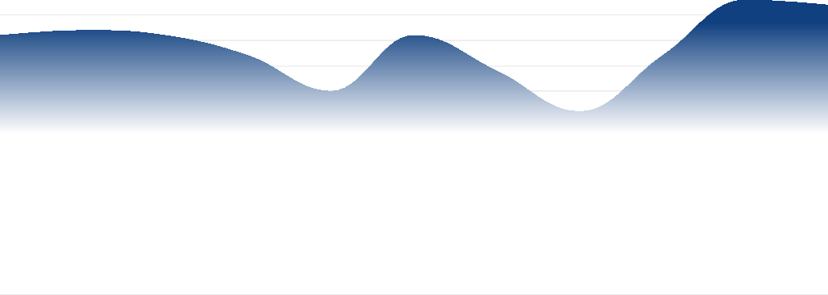
7
Forecasted

6

5

4

3

2

1

0
2020 2025

Industry Risk Sector Risk Economy Risk

Sources: IBISWorld

Risk Score Trend Analysis

Overall risk in the Investment Banking & Securities Intermediation industry is forecast to be MEDIUM-HIGH over 2026. The primary negative factors affecting this industry are corporate profit and high competition. Overall risk will be higher than the MEDIUM level of the previous year, a result of unfavorable movements in S&P 500 as well as initial public offerings. Additionally, growth risk is projected to rise.

Risk Score Context

In 2026, the average risk score for all US industries is expected to be in the MEDIUM band. Furthermore, the risk score for the Finance & Insurance sector, which includes this industry, is at a MEDIUM-HIGH level. Therefore, the level of risk in the Investment Banking & Securities Intermediation industry will be higher than that of the US economy and similar to the Finance & Insurance sector.

Structural Risk Analysis

Structural risk will be HIGH over the outlook period. This industry struggles with high competition. Businesses competing for market share must incur expenses to differentiate offerings or keep prices low to entice demand. This results in greater likelihood of declining revenue and lower profits. Operators are exposed to high revenue volatility. This requires prudent cash flow management and planning in times of uncertain demand. Businesses failing to account for these challenges risk sudden losses or diminished margins. This industry is currently in the mature phase of its life cycle which exhibits limited growth in demand opportunities and forces operators to compete for the remaining sales in order to survive.

Growth Risk Score Analysis

Growth risk is expected to be HIGH over the outlook period. IBISWorld forecasts that annual industry revenue will decline 1.9% to $481.7 billion. In comparison, revenue expanded 3.7% per year between 2023 and 2025.

Sensitivity Risk Analysis

Sensitivity risk is forecast to be MEDIUM over the outlook period, up from MEDIUM-LOW in 2025. The two factors with the most significant impacts on the industry are S&P 500 and corporate profit. A rise in either of these factors will lower industry risk.
SandP 500: The performance of the stock market heavily influences revenue for businesses. When equities markets perform well, the industry generates more revenue from trading activities and experiences increased demand from downstream clients for strategic advisory services. Growth in the S&P 500 index will help generate more revenue from trading activities, representing a potential opportunity for the industry. This factor's contribution to risk is expected to increase in the coming year.
Corporate profit: Changes in corporate profit influence the performance of equities markets because they impact how companies are valued,

influencing trading and business activity. Higher trading and business activity levels enable investment banks to earn higher trading, underwriting and advisory revenue. Growth in corporate profit will enhance some companies' valuations in the equities markets. This factor's contribution to risk is expected to increase in the coming year.
Initial public offerings: Investment banks help companies raise capital by underwriting their first sale of stock (equity) to public investors, known as an initial public offering (IPO). A high number of IPOs represents increased business demand for capital, which leads to higher underwriting revenue for the industry. Declines in the number of IPOs will pose a threat to the industry. This factor's contribution to risk is expected to increase in the coming year.
Investor uncertainty: Investor uncertainty is an essential measure of business sentiment and affects trading activity. Low investor uncertainty creates a favorable environment for IPO and M&A activity. However, trading activity may also benefit from investor uncertainty because asset fluctuations can lead to higher trading volumes. Growth in investor uncertainty can potentially limit trading activity, hindering revenue. This factor's contribution to risk is expected to decrease in the coming year.

Structural Risk

Structural Risk Score

Structure Component | Level | Trend | Weight (%) | Score
Barriers to Entry | Medium | Steady | 13 | 5.0
Competition | High | N/A | 20 | 9.0
Industry Exports | Low | Steady | 7 | 1.0
Industry Imports | Low | Steady | 7 | 2.0
Level of Assistance | None | Steady | 13 | 7.0
Life Cycle Stage | Mature | N/A | 20 | 5.0
Volatility of Industry | High | N/A | 20 | 7.0
Overall Structural Risk Score | High | N/A | N/A | 6.0
Note
The structural risk score reflects how an industry's fundamental characteristics affect its overall risk. Seven components are evaluated individually, then weighted and combined to calculate the score.

Barriers to Entry
Moderate
Steady

Differentiation

- New entrants must differentiate themselves from established competitors to gain a foothold in the market. With longstanding firms already holding string client relationships and reputations, attracting customers becomes difficult. This need for differentiation, combined with customer loyalty to established brands, raises barriers.

Legal

- The industry faces significant legal barriers to entry due to extensive government regulation. Firms must comply with complex laws and maintain specific levels of capital reserves. These regulatory obligations generate substantial compliance costs, making it challenging for new or small firms to effectively compete.

Start-Up Costs

- Establishing a new firm requires significant upfront investments in technology, skilled personnel and capital reserves. New entrants often struggle to compete with established firms, which benefit from economies of scale, extensive client networks and strong reputations. These high start up costs can discourage new entrants.

Labor Expenses

- New firms must hire experienced professionals, such as analysts, traders and advisors, whose expertise is essential for providing reliable investment services and research. These skilled employees are critical for a firm's reputation and competitiveness, driving up initial operating expenses for industry companies.

Competition
High
Increasing

- Zero commission fees on trading push companies to create better user experiences. The securities broker with the prettiest, most intuitive and most helpful user interface wins.
- Economies of scale are essential. Investment banking and securities intermediators with the best and most cost-effective technological networks are more competitive.

Domestic And International Markets

Exports

Low
Imports
Low
Steady
Steady

Assistance
None
Steady

Private support doesn't apply to the industry

- The Investment Banking & Securities Intermediation industry doesn't receive any private sector support.

The Troubled Asset Relief Program

- The Securities Brokerage industry only receives direct government assistance in response to financial emergencies. In response to the 2008 financial crisis, the government enacted the Troubled Asset Relief Program (TARP) to aid industry operators. For example, Wells Fargo received $25.0 billion and Bank of America received $20.0 billion to cover mortgage loan defaults and mortgage-backed securities losses. These funds aided in stabilizing the financial system and sustaining operations of key banks.

Life Cycle
Mature

Contribution to GDP

- The industry is growing at a faster pace than the US GDP, demonstrating robust growth in the financial sector. Despite the industry being in the mature phase of its life cycle, increased regulatory measures and strong market acceptance of its products and services drive continued contribution to economic expansion.

Innovation

- Innovation is limited in the industry. Investment products have yet to see much change since the Great Recession. The most significant innovations are the advances in new technology and the overall digitization of the industry. New technologies like AI and data analytical tools enhance industry companies' abilities to analyze large data sets and identify trends leading to potential investment opportunities.

Market Saturation

- The influx of new companies in the industry has increased market saturation. Companies offer similar products and seek to differentiate themselves by competing on pricing strategies and introducing innovative technological services to differentiate themselves and capture market share. Smaller niche players can compete by leveraging specialized expertise and personalized client services.

Consolidation

- Consolidation is limited but prevalent. The need for faster technological networks pushes smaller brokerage firms to consolidate to maximize profit and lower costs. However, the influx of new players has limited consolidation as new, smaller players seek to compete with well-established companies.

Technology & Systems

- The industry's use of telecommunications services, information technologies and electronic distribution technologies is increasing rapidly. The industry's technology improves the efficiency and effectiveness of information delivery and services to clients. By embracing cutting-edge technology systems, the industry can provide clients with faster and more reliable financial solutions.

Volatility
High

Regulatory changes significantly increase revenue volatility

- Government actions, like changes to tax laws, can affect revenue. Investment banking and securities intermediators must be vigil and financially prepared for new regulations. Monitoring and preparing for policy shifts enable investment banks to mitigate risks and

leverage investment opportunities that may arise from these regulatory changes.
- New rules and regulations can alter company operations and limit product offerings, causing shifts in demand and market dynamics. Stricter regulatory requirements often increase industry costs, potentially hindering revenue and profit growth for the industry.

Revenue fluctuates with market cycles

- Revenue volatility is primarily driven by shifts in fees and trading gains, both of which are influenced by broader macroeconomic trends. The industry typically experiences elevated revenues when economic and financial market conditions are strong. Growth in the S&P 500 has been a strong driver of revenue growth.
- Conversely, when financial markets decline, revenue tends to fall sharply. Lower investor confidence in sharp market downturns typically reduces the number of clients and business opportunities for investment banking and securities intermediators. Although, investor uncertainty has fallen over the past five years, boosting the number of clients and business opportunities.

Investment performance heavily influences revenue

- Industry revenue is highly sensitive to market performance. Shifts in market conditions, interest rates and global economic events can cause substantial fluctuations in trade values and overall financial results. In particular, interest rate changes play a crucial role in shaping the industry's revenue trends.
- When interest rates are high, investors typically shifts to bonds and other less risky assets with offer more predictable returns. As interest rates are cut, investors will increasingly shift to equities and more risky assets. Changes in investment performance can impact demand for products and services, resulting in revenue volatility.

Growth Risk

Growth Risk Score

Growth Component | Level | Revenue (%) | Weight (%) | Score
2024-2026 Annualized growth | Medium - Low | 3.7 | 25 | 4.2
2026-2027 Forecast growth | Very High | -1.9 | 75 | 7.7
Overall Growth Risk Score | High | N/A | N/A | 6.8
Note
The growth risk score compares an industry's forecasted revenue growth with its past performance and with expected growth across all industries. Higher growth rates generally indicate lower risk for industry operators.

Growth Risk Analysis
Strong returns in various financial markets and increased trading volumes have benefited businesses in the industry. Companies provide underwriting, brokering and market-making services for different financial instruments, including bonds, stocks and derivatives. Businesses benefited from improving macroeconomic conditions despite the high-interest-rate environment for most of the period due to inflationary pressures. However, the anticipation of interest rate cuts in the current year can limit interest income from fixed-income securities. As interest rates fall, fixed income securities will experience an outflow of capital and equities will experience an inflow of funds. The Fed is monitoring inflation, employment figures and the effects of tariffs along with other economic factors before making rate cut decisions. Overall, revenue has been growing at a CAGR of 8.5% to $491.0 billion over the past five years, including an expected increase of 1.8% in 2025 alone. Industry profit has grown during the same time due to greater interest income from bonds and will comprise 16.2% of revenue in the current year.
While many industries struggled at the onset of the period due to economic disruptions stemming from the volatile economic environment and supply chain issues, businesses benefited from the volatility. Primarily, companies have benefited from increased trading activity on behalf of their clients due to fluctuations in asset prices. This has led to higher trade execution fees for firms at the onset of the period. Similarly, debt underwriting increased as many businesses have turned to investment bankers to help raise cash for various ventures. Also, improved scalability of operations, especially regarding trading services conducted by securities intermediaries, has helped increase industry profits.
Structural changes have forced the industry's smaller businesses to evolve. Because competing in trading services requires massive investments in technology and compliance, boutique investment banks have alternatively focused on advising in merger and acquisition (M&A) activity. Boutique investment banks' total share of M&A revenue is forecast to grow through the end of 2030. Furthermore, the industry will benefit from improved macroeconomic conditions as inflationary pressures are expected to ease. This will help asset values rise and interest rate levels to be cut, thus allowing operators to generate more from equity underwriting and lending activities. Overall, revenue is forecast to grow at a CAGR of 1.4% to $526.8 billion over the five years to 2030.

Sensitivity Risk

Sensitivity Risk Score

Sensitivity Component | Level | Weight (%) | Score
S&P 500 | Low | 35 | 3.4
Corporate profit | Very High | 25 | 8.0
Initial public offerings | Medium - Low | 20 | 4.6
Investor uncertainty | Medium | 20 | 5.1
Overall Sensitivity Risk Score | Medium | N/A | 5.1
Note
We calculate sensitivity risk by examining external and exogenous factors that affect risk within the industry. Examples include input costs, number of housing starts, commodity prices, etc. This component contributes to 50% of the overall score.

Sensitivity Risk Analysis S&P 500

Estimated Value in 2026

7721.9 Index

2021-26 CAGR

2025-26 Change
Forecast Value in 2031

10086.1 Index
1 0.1 %
1 2.8 %

2026-31 CAGR

2026-27 Change
5 .5 %
5 .7 %

S&P 500
The percentage change in real household disposable income from 1980-2032

12,000 Index
Forecasted

45%

10,000 Index 30%

8,000 Index 15%

6,000 Index 0%

4,000 Index -15%

2,000 Index -30%

0 Index

1980 1985 1990 1995 2000 2005 2010 2015 2020 2025 2030
-45%

S&P 500 (Index) Change (%)

Sources: IBISWorld

Year | Index | Change  (%)
1980 | 137.2 | N/A
1981 | 126.1 | -8.1
1982 | 138.7 | 10.0
1983 | 166.5 | 20.0
1984 | 163.6 | -1.7
1985 | 211.3 | 29.2
1986 | 242.2 | 14.6
1987 | 247.1 | 2.0
1988 | 277.7 | 12.4
1989 | 353.4 | 27.3
1990 | 330.2 | -6.6
1991 | 417.1 | 26.3
1992 | 435.7 | 4.5
1993 | 466.5 | 7.1
1994 | 459.3 | -1.5
1995 | 615.9 | 34.1
1996 | 740.7 | 20.3
1997 | 970.4 | 31.0

Year Index Change
(%)

1998 | 1229.2 | 26.7
1999 | 1469.3 | 19.5
2000 | 1320.3 | -10.1
2001 | 1148.1 | -13.0
2002 | 879.8 | -23.4
2003 | 1111.9 | 26.4
2004 | 1211.9 | 9.0
2005 | 1248.3 | 3.0
2006 | 1418.3 | 13.6
2007 | 1468.4 | 3.5
2008 | 903.3 | -38.5
2009 | 1115.1 | 23.5
2010 | 1257.6 | 12.8
2011 | 1257.6 | 0.0
2012 | 1426.2 | 13.4
2013 | 1848.4 | 29.6
2014 | 2058.9 | 11.4
2015 | 2043.9 | -0.7
2016 | 2238.8 | 9.5
2017 | 2673.6 | 19.4
2018 | 2506.9 | -6.2
2019 | 3230.8 | 28.9
2020 | 3756.1 | 16.3
2021 | 4766.2 | 26.9
2022 | 3839.5 | -19.4
2023 | 4769.8 | 24.2
2024 | 5881.6 | 23.3
2025 | 6845.5 | 16.4
2026 | 7721.9 | 12.8
2027 | 8160.8 | 5.7
2028 | 8617.8 | 5.6
2029 | 9118.0 | 5.8
2030 | 9651.3 | 5.8
2031 | 10086.1 | 4.5
2032 | 10519.6 | 4.3

The Standard & Poor's 500 stock index (S&P 500) is a commonly cited indicator of stock market performance. It is a scaled average of 500 large-capitalization common stocks in the United States. The companies in the index operate across all sectors of the economy, including energy, finance, telecommunications, retail and manufacturing. The values presented in this report are the December 31 close figures. Data is sourced from the St. Louis Federal Reserve.

Current Performance

In 2026, the S&P 500 is projected to close the year 12.8% higher, but the index's pace of appreciation is easing from the breakneck gains of 2023–2025 as investors digest earlier policy and earnings surprises. Reciprocal tariffs announced in early 2025 injected short-term uncertainty into global supply chains, briefly cooling risk appetite before subsequent pauses and fresh trade agreements restored confidence. Market sentiment strengthens as the Trump administration's tax cuts feed through to after-tax earnings and buybacks, while mid-decade rate cuts reduce discount rates and support equity valuations, even as periodic volatility flares around labor-market releases and Fed guidance.
From 2021 through 2026, the S&P 500 posted a robust compound growth rate of 10.1%, but the path was jagged as the index cycled from pandemic recovery to inflation shock and then to an AI-led rally. In 2021, strong post-COVID earnings and vaccine-driven reopening momentum kept equities buoyant, though waves of new variants periodically rattle sentiment. The backdrop shifts abruptly in 2022 as the Federal Reserve executes one of the most aggressive tightening campaigns in decades, lifting policy rates sharply just as the war in Ukraine and lingering supply bottlenecks push inflation higher, driving a deep single-year drawdown in the index. By 2023 and 2024, the market pivots back to powerful gains as investors rotate into technology and communication services on enthusiasm for artificial intelligence and productivity-enhancing software, pushing the S&P 500 to repeated record closes despite still-elevated rates. Through this five-year window, shifting trade policy, evolving supply-chain strategies and intermittent fiscal support repeatedly reprice risk, yet the index shows remarkable resilience, recovering quickly from shocks as investors adapt to a higher-rate, innovation-heavy environment.

Outlook

In 2027, the S&P 500 is expected to notch another year of meaningful gains, gaining 5.7%, as markets lean into the prospect of deeper Fed easing and the earnings impact of prior tax cuts, even while headline risk around US-China trade keeps volatility elevated. Lower expected policy rates compress borrowing costs and underpin higher multiples, while stable consumer spending and continued strength in large-cap technology and communication names sustain top-line growth.
From 2026 to 2031, the S&P 500's projected 5.5% annualized growth reflects a transition from stimulus-charged recovery to more mature, policy-sensitive expansion. In 2031, the index will reach an estimated 10,086.1. Successive rate cuts are set to ease financing constraints for capital-intensive industries, encouraging investment in areas such as data centers, automation and domestic energy infrastructure, all of which support earnings and share repurchases. Additional deregulation and tax reductions promoted by the Trump administration reinforce profit, particularly for financials, energy and select industrials, while planned expansions in US energy production help limit operating costs for energy-intensive sectors. At the same time, renewed tariff threats and persistent geopolitical flashpoints introduce episodic downside risk, as higher trade barriers could reignite cost pressures and force the Fed to slow or reverse easing if inflation reaccelerates. Even under these pressures, ongoing innovation in technology, digital infrastructure and health care, coupled with resilient household demand, positions the index to maintain a positive trajectory through 2031 rather than revert to the crisis-era volatility that defined the early 2020s.

Corporate profit

Estimated Value in 2026

$4271.8 billion

2021-26 CAGR

2025-26 Change
Forecast Value in 2031

$5602.2 billion
6 .6 %
3 .9 %

2026-31 CAGR

2026-27 Change
5 .6 %
6 .1 %

Corporate profit
The percentage change in real household disposable income from 1980-2032
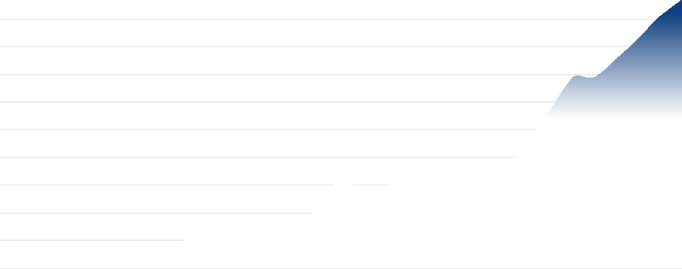
7,200 billion
Forecasted

48%

6,000 billion 36%

4,800 billion 24%

3,600 billion 12%

2,400 billion 0%

$1,200 billion -12%

$0 billion -24%
1980 1985 1990 1995 2000 2005 2010 2015 2020 2025 2030

Corporate profit ($billion) Change (%)

Sources: IBISWorld

Year | $ billion | Change  (%)
1980 | 240.2 | N/A
1981 | 250.4 | 4.3
1982 | 222.7 | -11.1
1983 | 254.6 | 14.3
1984 | 293.6 | 15.3
1985 | 288.3 | -1.8
1986 | 272.4 | -5.5
1987 | 319.4 | 17.2
1988 | 368.0 | 15.2
1989 | 377.5 | 2.6
1990 | 392.8 | 4.0
1991 | 430.4 | 9.6
1992 | 463.9 | 7.8
1993 | 508.1 | 9.5
1994 | 598.6 | 17.8
1995 | 677.4 | 13.2
1996 | 755.9 | 11.6
1997 | 831.1 | 10.0

Year $ billion Change
(%)

1998 | 770.5 | -7.3
1999 | 793.8 | 3.0
2000 | 769.6 | -3.0
2001 | 725.6 | -5.7
2002 | 815.7 | 12.4
2003 | 976.1 | 19.7
2004 | 1248.3 | 27.9
2005 | 1670.2 | 33.8
2006 | 1861.7 | 11.5
2007 | 1770.5 | -4.9
2008 | 1403.9 | -20.7
2009 | 1508.3 | 7.4
2010 | 1831.1 | 21.4
2011 | 1802.2 | -1.6
2012 | 2203.9 | 22.3
2013 | 2234.1 | 1.4
2014 | 2356.1 | 5.5
2015 | 2295.5 | -2.6
2016 | 2245.2 | -2.2
2017 | 2247.5 | 0.1
2018 | 2266.6 | 0.8
2019 | 2376.0 | 4.8
2020 | 2503.8 | 5.4
2021 | 3110.4 | 24.2
2022 | 3445.9 | 10.8
2023 | 3888.2 | 12.8
2024 | 4170.2 | 7.3
2025 | 4112.3 | -1.4
2026 | 4271.8 | 3.9
2027 | 4533.3 | 6.1
2028 | 4787.1 | 5.6
2029 | 5067.2 | 5.8
2030 | 5371.2 | 6.0
2031 | 5602.2 | 4.3
2032 | 5811.5 | 3.7

This item refers to corporate profit earned across all industries. Profit is calculated by subtracting the value of the following from revenue: wages after inventory valuation and capital consumption adjustments. Data is sourced from the Bureau of Economic Analysis and is presented in 2017 dollars.

Current Performance

Corporate profit is anticipated to decrease by 3.9% in 2026, reaching $4,271.83 billion. Interest rate cuts toward the end of 2024 and in 2025 are expected to lower financing costs and bolster business investment. Steady consumer demand, resilient job markets and record-level earnings from large technology firms will support profit. However, tariffs are projected to raise input costs for businesses reliant on imports, limiting profit gains.
From 2021 through 2026, corporate profit has shown robust recovery and subsequent moderation. Margins remained resilient despite ongoing supply chain disruptions from the COVID-19 pandemic and rising inflation. In 2021, profit rebounded significantly, expanding by 24.2% as economic activity accelerated. Growth continued at 10.8% in 2022 as companies passed higher costs onto consumers, maintaining robust margins despite inflationary pressure. In 2023, profit increased by 9.9%, with interest rate hikes beginning to temper consumption and raise borrowing expenses, but strong performances among large technology companies continued to drive growth.
By 2024, high interest rates persisted, but resilient labor markets and strong consumer spending sustained an estimated 7.3% growth in profit. Monetary policy began to shift in late 2024, with rate cuts easing pressure on corporate financing. Macroeconomic trends like digital technology adoption, globalized supply chains and productivity enhancements contributed to profit stability. Meanwhile, cost pressures from labor and energy markets, as well as shifting trade and tariff regimes, intermittently constrained growth.
From 2020 to 2025, corporate profit grew at a CAGR of 10.1%, reflecting a post-pandemic rebound followed by normalization as disruptions waned. Macro trends, including strong consumer demand, capital investment in technology and labor market adjustments, played critical roles. However, evolving tariffs, global supply chain shifts and persistent inflation underscored ongoing risks to profit.

Outlook

Corporate profit is forecast to increase by 6.1% in 2027. AI-driven efficiency gains are a leading catalyst for US corporate profit growth heading into 2027. Strong earnings are set to be powered by positive operating leverage, AI-fueled productivity, accommodating tax and regulatory policy and increased M&A activity, particularly benefiting financials, industrials and healthcare.
From 2025 to 2031, corporate profit levels are expected to grow, with profit expect to reach $5,602.17 billion by 2031. Deregulatory measures may create a more business-friendly environment, but these benefits could be offset by rising operational costs tied to tariffs, labor expenses, and regulatory compliance. Companies may increase domestic production and invest in automation, though high initial costs will temper immediate profitability gains. Labor union activity is anticipated to pressure wages, further constraining growth.
Shifts in tax policy, with some states lowering corporate tax rates, may slightly ease the corporate tax burden. Firms might recapture increased costs through higher prices for goods and services, but consumer tolerance for price increases may be tested amid inflation expectations and economic uncertainty. Over the next five years, profit expansion will be limited by these converging trends, despite opportunities for growth among firms investing in efficiency improvements and automation.

Initial public offerings

Estimated Value in 2025

$54.13 billion

2020-25 CAGR

2024-25 Change
Forecast Value in 2030

$54.78 billion
- 7.1 %
8 2.9 %

2025-30 CAGR

2025-26 Change
0 .2 %
2 .0 %

Initial public offerings
The percentage change in real household disposable income from 2002-2031
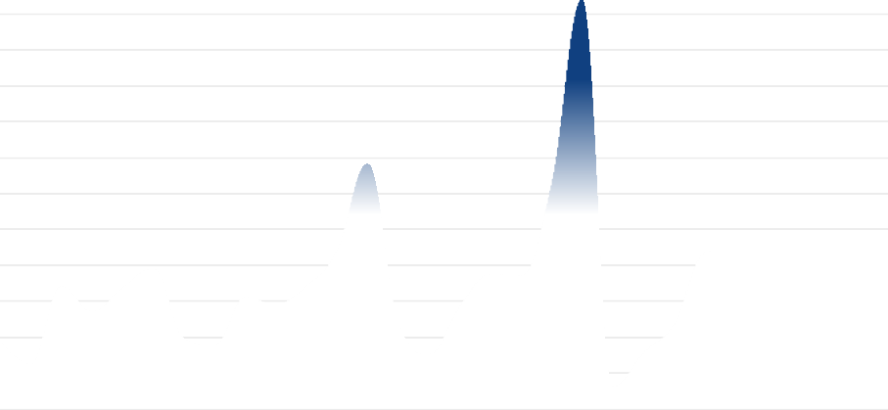
$150 billion
Forecasted

240%

$125 billion 180%

$100 billion 120%

$75 billion 60%

$50 billion 0%

$25 billion -60%

$0 billion

2005 2010 2015 2020 2025 2030
-120%

Initial public offerings ($billion) Change (%)

Sources: IBISWorld

Year | $ billion | Change  (%)
2002 | 23.50 | N/A
2003 | 15.40 | -34.5
2004 | 42.80 | 177.9
2005 | 33.70 | -21.3
2006 | 42.10 | 24.9
2007 | 49.00 | 16.4
2008 | 24.50 | -50.0
2009 | 21.80 | -11.0
2010 | 38.70 | 77.5
2011 | 36.30 | -6.2
2012 | 42.70 | 17.6
2013 | 54.90 | 28.6
2014 | 85.30 | 55.4
2015 | 30.00 | -64.8
2016 | 18.80 | -37.3
2017 | 35.50 | 88.8
2018 | 46.90 | 32.1
2019 | 46.30 | -1.3

Year $ billion Change
(%)

2020 | 78.20 | 68.9
2021 | 142.4 | 82.1
2022 | 7.70 | -94.6
2023 | 19.50 | 153.2
2024 | 29.60 | 51.8
2025 | 54.13 | 82.9
2026 | 55.21 | 2.0
2027 | 55.09 | -0.2
2028 | 54.76 | -0.6
2029 | 54.73 | 0.0
2030 | 54.78 | 0.1
2031 | 54.75 | -0.1

This driver measures the total annual sales proceeds of initial public offerings (IPOs) executed in the United States. Data is sourced from Renaissance Capital LLC.

Current Performance

In 2025, the value of initial public offerings (IPOs) is estimated at $54.1 billion, marking an 82.9% increase from the previous year. This performance reflects improved market sentiment after a relatively slow start to the year amid tariffs and general market uncertainty. Technology, media and telecommunications have been bright spots. Potential disruptions from further tariffs or geopolitical tensions could derail expected growth for the year.
Between 2020 and 2025, IPO activity exhibited high volatility, following global economic and capital market conditions. In 2021, IPO proceeds peaked at $142.4 billion driven by increased activity, notably through Special Purpose Acquisition Companies (SPACs). This record year resulted from a surge in liquidity, favorable market conditions and strong business sentiment as the world emerged from early COVID-19 disruptions.
However, from 2022 onward, the market faced a significant correction. IPO values fell to $7.7 billion in 2022, steadily growing from that low in the years since. The contraction was primarily attributed to rising interest rates, ongoing inflation and heightened volatility from lingering pandemic effects. During this period, investor caution increased and capital was increasingly allocated to less volatile assets. The diminished IPO pipeline corresponded closely with tightening global financial conditions and declining stock market indices. The inflation-driven rise in government bond yields further diverted potential capital away from IPOs.
The proliferation and subsequent contraction of SPAC offerings between 2021 and 2025 was a defining feature, initially accelerating IPO activity but later contributing to market normalization as investor scrutiny increased. Macroeconomic headwinds, including supply chain disruptions and geopolitical instability, also exerted downward pressure on IPO volumes. Collectively, these trends resulted in a negative CAGR of 7.1% over the five-year period, highlighting the sensitivity of IPO activity to broader economic conditions, investment sentiment, and shifts in global financial markets.

Outlook

In 2026, IPO proceeds are forecast to increase, reaching $55.2 billion, a 2.0% increase from 2025. The moderate growth reflects a cautious investment environment as private companies delay listing plans amid uncertain capital market prospects.
Over the 2026-2030 period, IPO proceeds are projected to continue increasing but at a low rate, reaching $54.8 billion by 2030. The forecast assumes gradual easing of inflationary pressures as government monetary policy becomes more accommodative. This shift is expected to stabilize borrowing costs and improve business sentiment, allowing for increased, albeit restrained, IPO activity. The ongoing presence of SPACs is anticipated to provide alternative listing opportunities, though at a lower volume than the peak observed in 2021. Trends such as evolving investor risk profiles, continued macroeconomic uncertainty and the relative attractiveness of fixed-income assets are likely to shape IPO activity during this period. The recovery in IPO volumes will remain contingent on broader capital market stabilization and the resurgence of investor confidence.

Investor uncertainty

Estimated Value in 2026

20.2%

2021-26 AAGR

2025-26 Change

Forecast Value in 2031

20.9%
0 .1 pp
1 .2 pp

2026-31 AAGR

2026-27 Change
0 .2 pp
0 .6 pp

Investor uncertainty
The percentage change in real household disposable income from 1990-2032
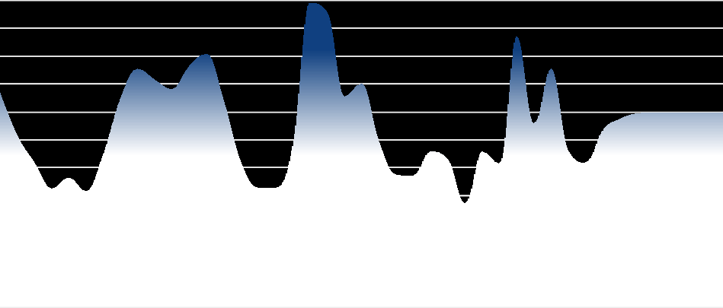
36%
Forecasted

18 pp

30% 12 pp

24% 6 pp

18% 0 pp

12% -6 pp

6% -12 pp

0%
1990 1995 2000 2005 2010 2015 2020 2025 2030
-18 pp

Investor uncertainty (%) Change (pp)

Sources: IBISWorld

Year | % | Change  (pp)
1990 | 23.0 | N/A
1991 | 18.4 | -4.7
1992 | 15.5 | -2.9
1993 | 12.7 | -2.8
1994 | 13.9 | 1.2
1995 | 12.4 | -1.6
1996 | 16.4 | 4.1
1997 | 22.4 | 6.0
1998 | 25.6 | 3.1
1999 | 24.4 | -1.1
2000 | 23.4 | -1.1

Year % Change
(pp)

2001 | 25.9 | 2.6
2002 | 27.2 | 1.3
2003 | 22.1 | -5.1
2004 | 15.5 | -6.6
2005 | 12.8 | -2.7
2006 | 12.8 | 0.0
2007 | 17.4 | 4.7
2008 | 32.7 | 15.2
2009 | 31.7 | -1.0
2010 | 22.6 | -9.1
2011 | 24.0 | 1.4
2012 | 17.8 | -6.2
2013 | 14.2 | -3.6
2014 | 14.1 | -0.1
2015 | 16.7 | 2.5
2016 | 15.9 | -0.8
2017 | 11.1 | -4.8
2018 | 16.7 | 5.6
2019 | 15.4 | -1.4
2020 | 29.1 | 13.7
2021 | 19.7 | -9.4
2022 | 25.6 | 5.9
2023 | 16.8 | -8.8
2024 | 15.5 | -1.3
2025 | 19.0 | 3.5
2026 | 20.2 | 1.2
2027 | 20.8 | 0.6
2028 | 20.9 | 0.1
2029 | 20.9 | 0.0
2030 | 20.9 | 0.0
2031 | 20.9 | 0.0
2032 | 20.9 | 0.0

Investor uncertainty, nicknamed "the fear index," tracks the VIX-CBOE Volatility Index, which measures the prices of various call and put options for the S&P 500. A higher value represents greater uncertainty in the future price of the S&P 500. Annual totals represent an equally weighted average of the monthly mean value of the index, calculated as the average of the adjusted close for every trading day during a particular month. Data is sourced from the Chicago Board Options Exchange.

Current Performance

In 2026, investor uncertainty is set to continue to increase, with the VIX projected to rise 6.4% to reach an average index value of 20.2, after already rising 22.3% in 2025. This shift from the easing trend in 2024 is primarily due to renewed concerns over US tariff implementation under a new administration, and, more recently, the conflict in Iran. After a period of stability from interest rate pauses and cuts, anticipated restrictive trade policies have prompted greater risk aversion and heightened market volatility.
From 2021 to 2025, investor uncertainty exhibited high volatility, influenced by health, geopolitical events and shifts in monetary policy. The volatility index returned near historical norms in 2021 after the pandemic shock, but uncertainty remained due to ongoing COVID-19 threats, renewed lockdowns in China, and supply chain disruptions. The US Federal Reserve's significant interest rate hikes in 2022, in response to rising inflation, spiked market uncertainty and triggered stock selloffs. The Russian invasion of Ukraine amplified global uncertainty, while escalating inflation rates impacted investor sentiment worldwide. By 2023, anticipation of a Federal Reserve pause in rate hikes reduced uncertainty, fostering optimism that avoided a severe downturn. The trend continued into 2024 with rate reductions, though the global economic environment remained sensitive to conflicts and policy changes.
During this period, macroeconomic factors such as fluctuating monetary policy, significant geopolitical events, and global health crises were central to shaping investor uncertainty. Inflationary pressures and their impact on economic policy influenced asset allocation and demand for safe-haven investments. The uncertainty index's sensitivity to domestic and international policies underscores the global interconnectedness of capital markets and the importance of stable macroeconomic conditions for investor confidence.
Over the five years to 2026, the investor uncertainty index increased at a CAGR of 0.5%, with volatility exposed to economic shocks and rapid policy shifts. The period was marked by alternating phases of risk aversion and optimism, closely tracking major policy decisions and external shocks.

Outlook

Investor uncertainty is expected to increase in 2027, with the volatility index rising to an index value of 20.8, a 3.2% increase from the prior year. This rise reflects ongoing concerns about US trade policy, geopolitical tensions and unresolved supply chain challenges.
From 2026 to 2031, investor uncertainty is forecast to stabilize, reaching 20.9 by 2031. Contributing factors include continued US protectionist policies and tensions with China, likely to disrupt global trade. Extreme weather events and climate disruptions may destabilize key commodity supply chains, adding financial market volatility. Global monetary policy will remain a source of uncertainty, as central banks navigate challenging inflationary conditions and evolving priorities.
International conflicts, such as the war in Ukraine and turbulence in the Middle East, will also influence by elevating geopolitical risk and dampening global investor sentiment. These forces are projected to sustain above-average levels of investor uncertainty, reflecting persistent macroeconomic headwinds and episodic shocks likely within the five-year window.

Risk Score Methodology

What is Industry Risk?
Industry risk is the difficulty or otherwise of operating in an industry. We calculate industry risk using non-financial information. We represent industry risk with forward-looking numerical scores for specific industries. Industry Risk Scores measure the expected risk for the upcoming 12 to 18 months.

Industry Risk Scoring Methodology
We represent industry risk on a scale of 1 to 9, where 1 represents the lowest risk, and 9 is the highest risk.Industry risk is broken down into Growth, Structure and Sensitivity risk, which are combined to calculate the overall risk score.

Growth: Growth risk is a combination of recent and forecast growth scores. Growth scores account for between 0 and 25% of the overall score.The base case contribution is 25%, which is dampened at inflection points where extreme declines produce misleading positive forecast growth.

Structure: We calculate structural risk by analyzing internal industry risk factors.These factors are an industry's volatility, barriers to entry, external assistance, trade exposure, imports and exports (if any), industry life cycle and amount of competition. When our analysis identifies that an external factor creates a transitory shift to industry structure, the ratings are subjected to a structural adjustment score. The structure score contributes 25% plus any contribution dampened from the growth score.

Sensitivity: We calculate sensitivity risk by examining external and exogenous factors that affect risk within the industry.Examples include input costs, number of housing starts, commodity prices, etc.This component contributes to 50% of the overall score.

Risk Rating Score Ranges

Very Low | Low | Medium-Low | Moderate | Medium-High | High | Very High
1.0-3.0 | 3.0-4.1 | 4.1-4.7 | 4.7-5.3 | 5.3-5.9 | 5.9-7.0 | 7.0-9.0

IBISWorld helps you find the industry information you need - fast.

Disclaimer
This product has been supplied by IBISWorld Inc. ('IBISWorld') solely for use by its authorized licenses strictly in accordance with their license agreements with IBISWorld. IBISWorld makes no representation to any other person with regard to the completeness or accuracy of the data or information contained herein, and it accepts no responsibility and disclaims all liability (save for liability which cannot be lawfully disclaimed) for loss or damage whatsoever suffered or incurred by any other person resulting from the use of, or reliance upon, the data or information contained herein. Copyright in this publication is owned by IBISWorld Inc. The publication is sold on the basis that the purchaser agrees not to copy the material contained within it for other than the purchasers own purposes. In the event that the purchaser uses or quotes from the material in this publication – in papers, reports, or opinions prepared for any other person – it is agreed that it will be sourced to: IBISWorld Inc. by IBISWorld on 10 August 2019 in accordance with their license agreement in IBISWorld

2026 IBISWorld. All Rights Reserved www.ibisworld.com

